~Asia-China-Mirror- Nebula and continuous Arc Design, Western Han Dynasty (206BBCE-9CE),

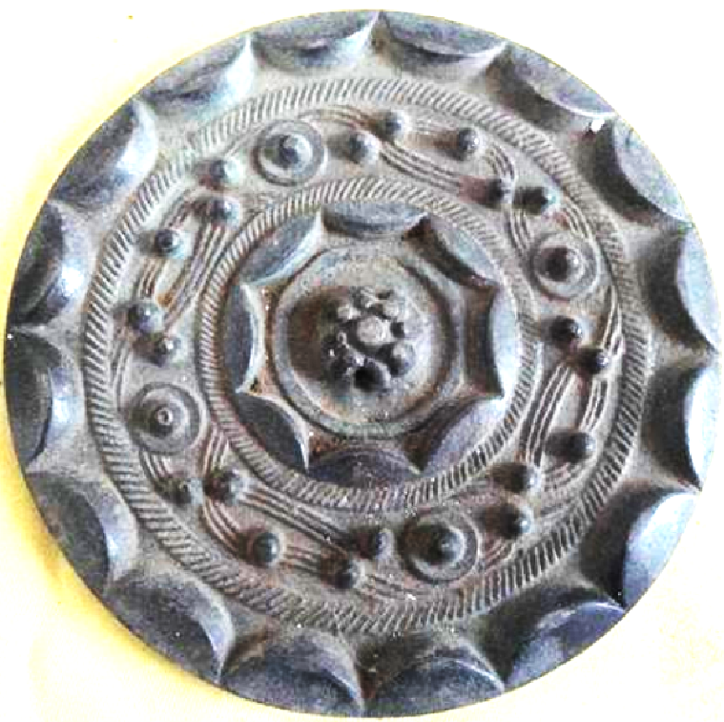

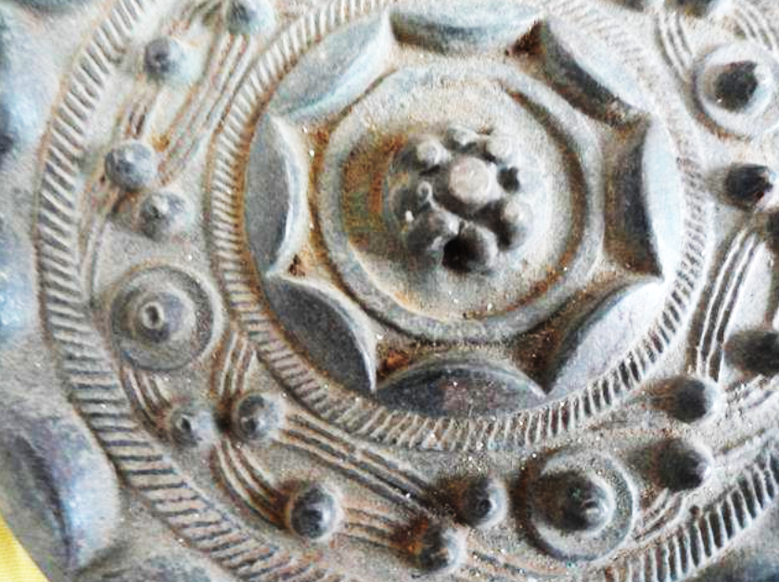

White bronze mirror with Nebula and continuous Arc Design, Western Han Dynasty (206BBCE-9CE), dia. 14 cm. Side slightly inclined in ward.

The continuous arc design was initiated in the Warring States period. This example has a thick rim of 16 continuous arcs with two internal bands of a rope-like design separating the "Nebula" configuration of nipples and curves from an inner rim of 8 continuous arcs surrounding a circle and a central boss with nine nipples.

The name "Nebula" deserves some comment. This was a term assigned to this type of mirror but in reality the design appears to be more like clouds swirling up from a groun, so Nakano suggests that "cloud whorl" pattern is more appropriate.

This design appears to suggest a cosmological scheme with the celestial firmament surrounding a central point.

References: Toru Nakano, *Bronze Mirrors from Ancient China* ([Hong Kong]: Orientations, 1994), pp. 120-121.